Narrative Text Structure

Objective
The student will identify story elements.

Story Mapping

Setting
Materials
Narrative text
Choose text within students’ instructional-independent reading level range.
Student sheet (Activity Master C.009.SS1) Pencil
Activity

Students record information related to story elements on a graphic organizer.
- Provide the student with a copy of the text and a student sheet.
- The student reads or reviews the text.
- Writes the title and author of the story on the student sheet.
- Reads the prompts and records the answers until the sheet is complete.
- Teacher evaluation

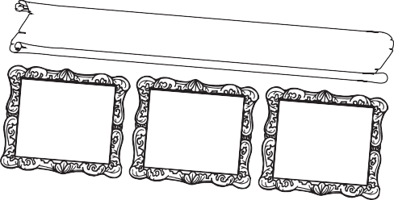

Extensions and Adaptations
Charact

Event

Event

Event

Event

Event

Solution:

2007 The Florida Center f
or Reading Resear
Use different colored highlighters to mark story elements on a copy of the text. Use other story maps (Activity Masters C.009.SS2 and C.009.SS3).
Write other questions about the story and exchange with a partner who answers

Name
Story Mapping
Title and Author

Character
Character
Character

Setting

Problem:

Event

Event

Event

Event

Solution:

Name
Story Mapping
Title: Author:
Setting
Where:
When:

Characters

Problem

Event

Event

Event

Event

Event

Solution

Who are the important characters in the story? Who is your favorite character and why?

What is the setting of the story?

What is the problem in the story?
What is the plot of the story?

What is the theme of the story?

Title/Author

Name
Story Mapping

C.009.SS3
2007 The Florida Center for Reading Research
4-5 Student Center Activities: Comprehension

What is the solution to the problem? What is another way the problem could have been solved?

Name
C.009.SS4 Story Mapping

4-5 Student Center Activities: Comprehension 2007 The Florida Center for Reading Research

